

**Lab Manual**

**Computer Engineering – Artificial Intelligence**

**B. Tech. Year – II, 5th Semester, Academic Year (2023)**

**Subject Code: 01AI0501**

*Subject Name: Advance Java programming*

*Name: Basid Al Siddik Shammo*

*Enrollment Number: 92100151052*

**PROGRAM-01:** Demonstrate Array List.

**CODE:**

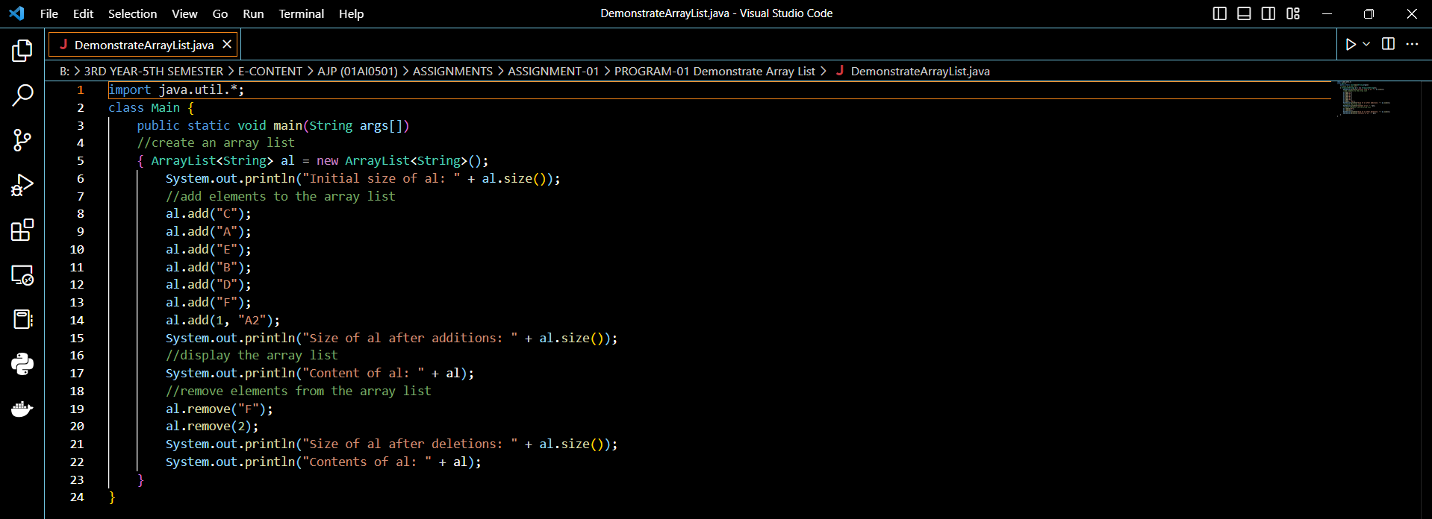

**Result-**

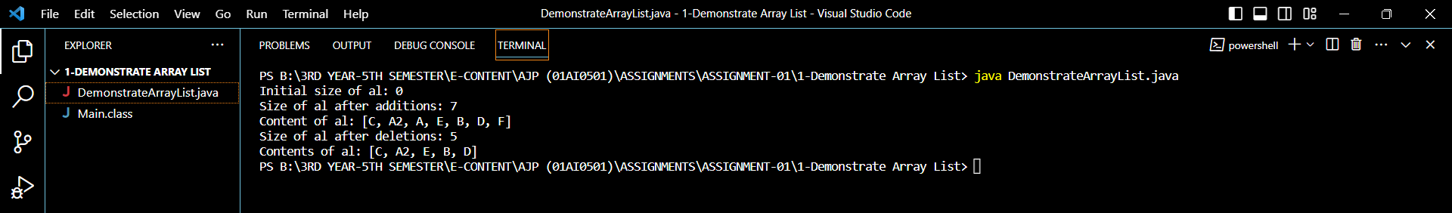

**PROGRAM-02:** Convert an Array List into an Array.

**CODE:**

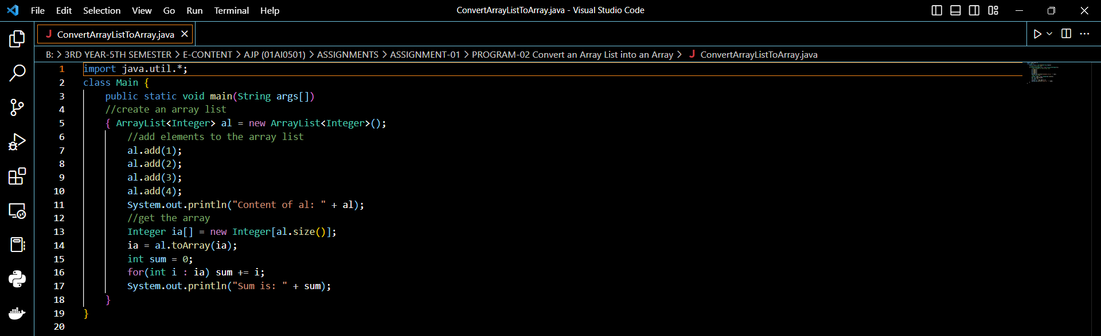

**Result-**

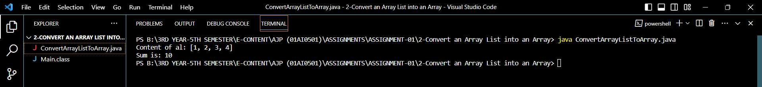

**PROGRAM-03:** Demonstrate LinkedList.

**CODE:**

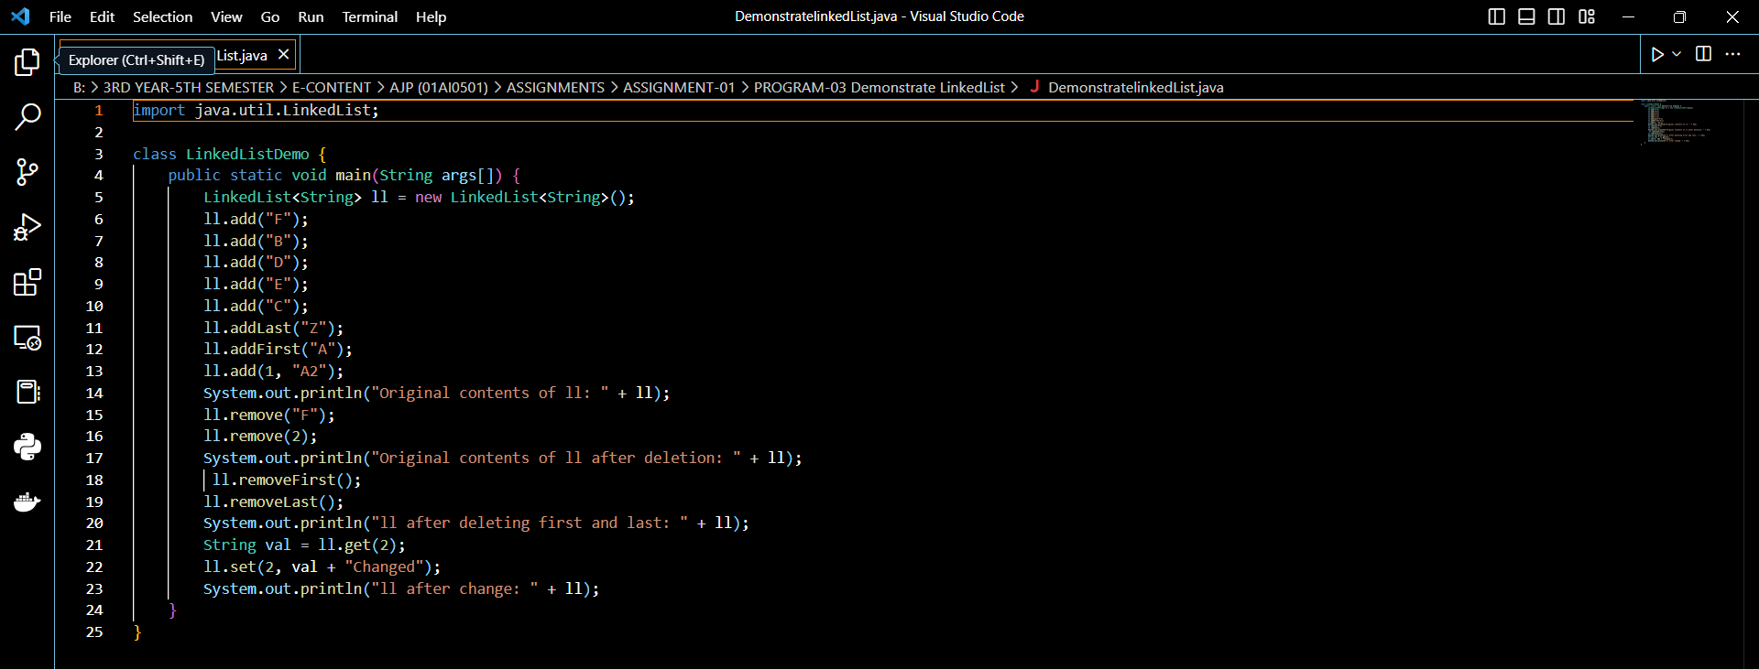

**Result-**

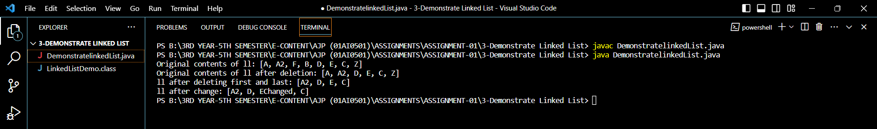

**PROGRAM-04:** Demonstrate HashSet.

**CODE:**

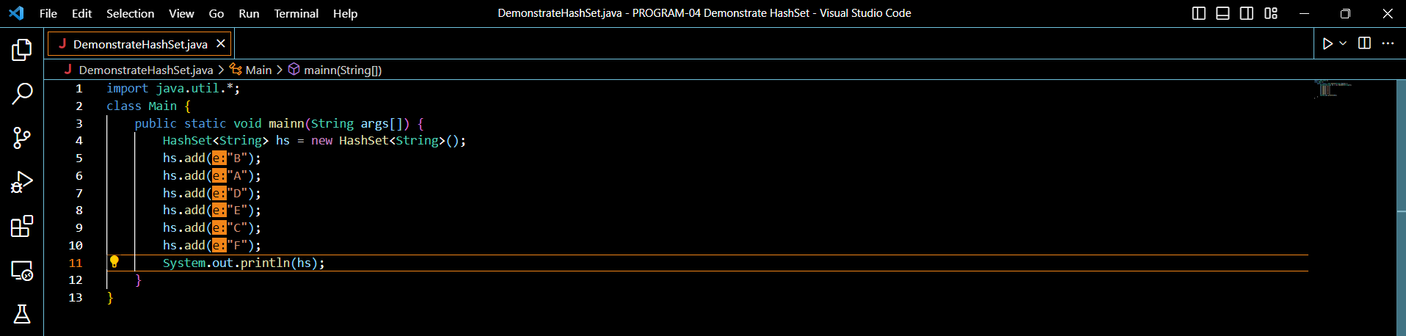

**Result-**

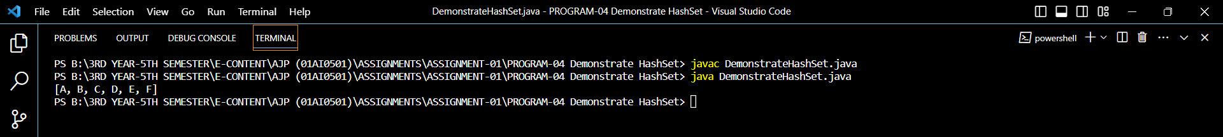

**PROGRAM-05:** Demonstrate TreeSet.

**CODE:**

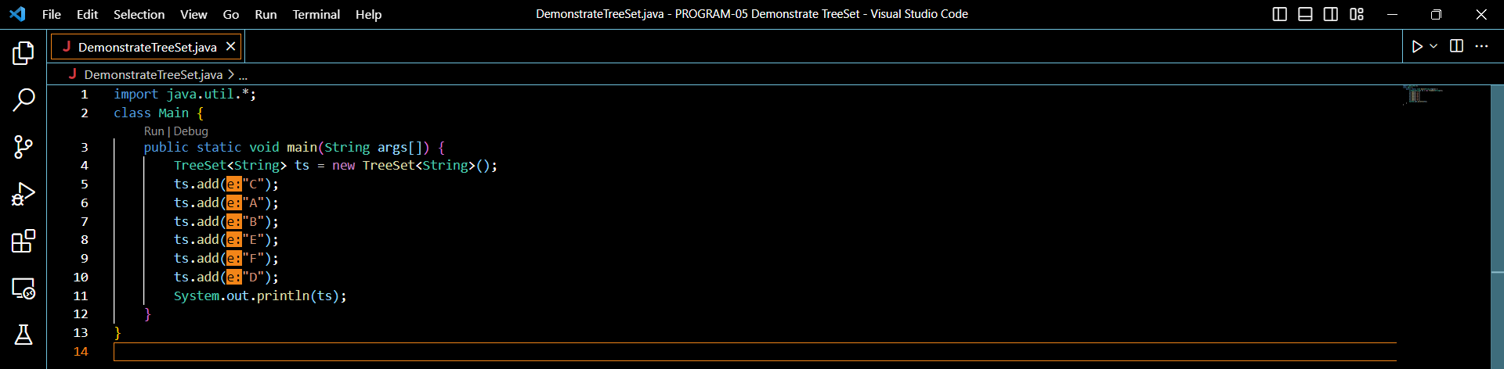

**Result-**

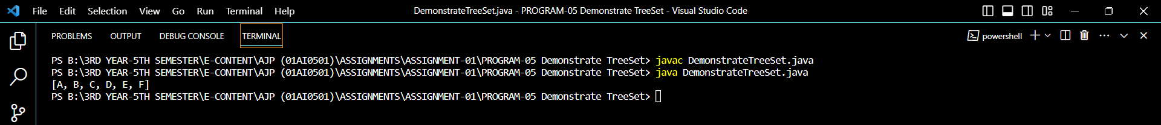

**PROGRAM-06:** Demonstrate ArrayDeque.

**CODE:**

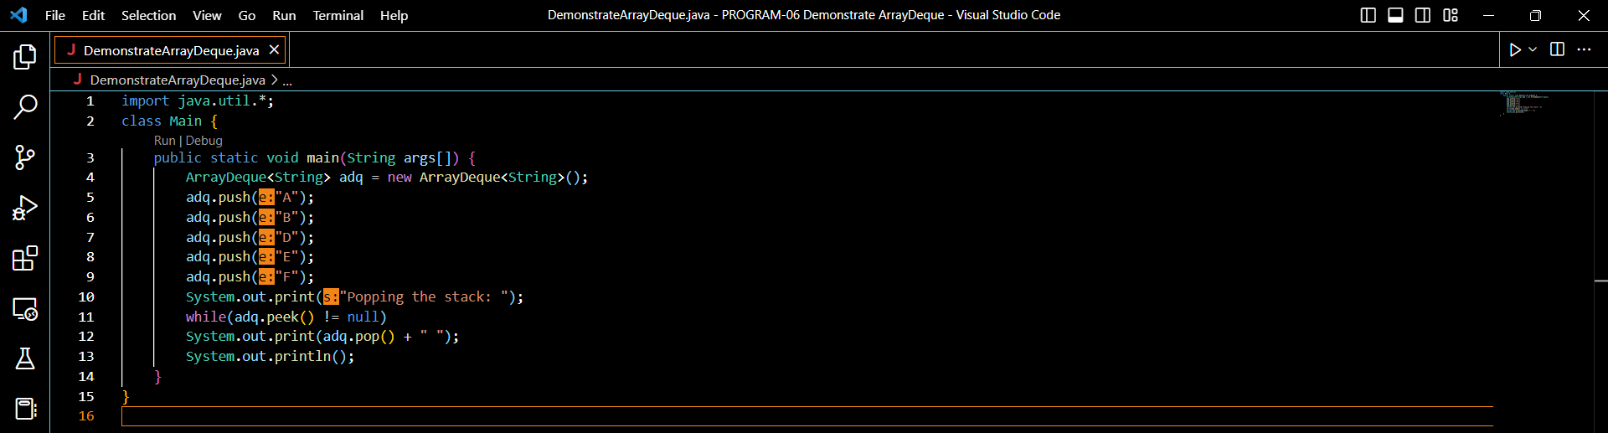

**Result-**

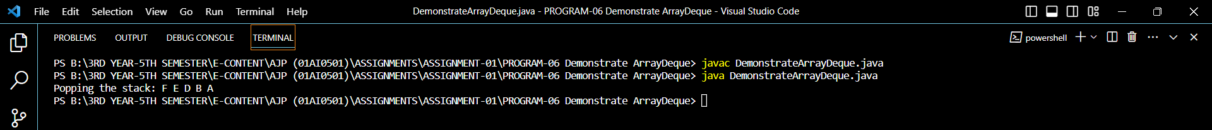

**PROGRAM-07:** Demonstrate iterators.

**CODE:**

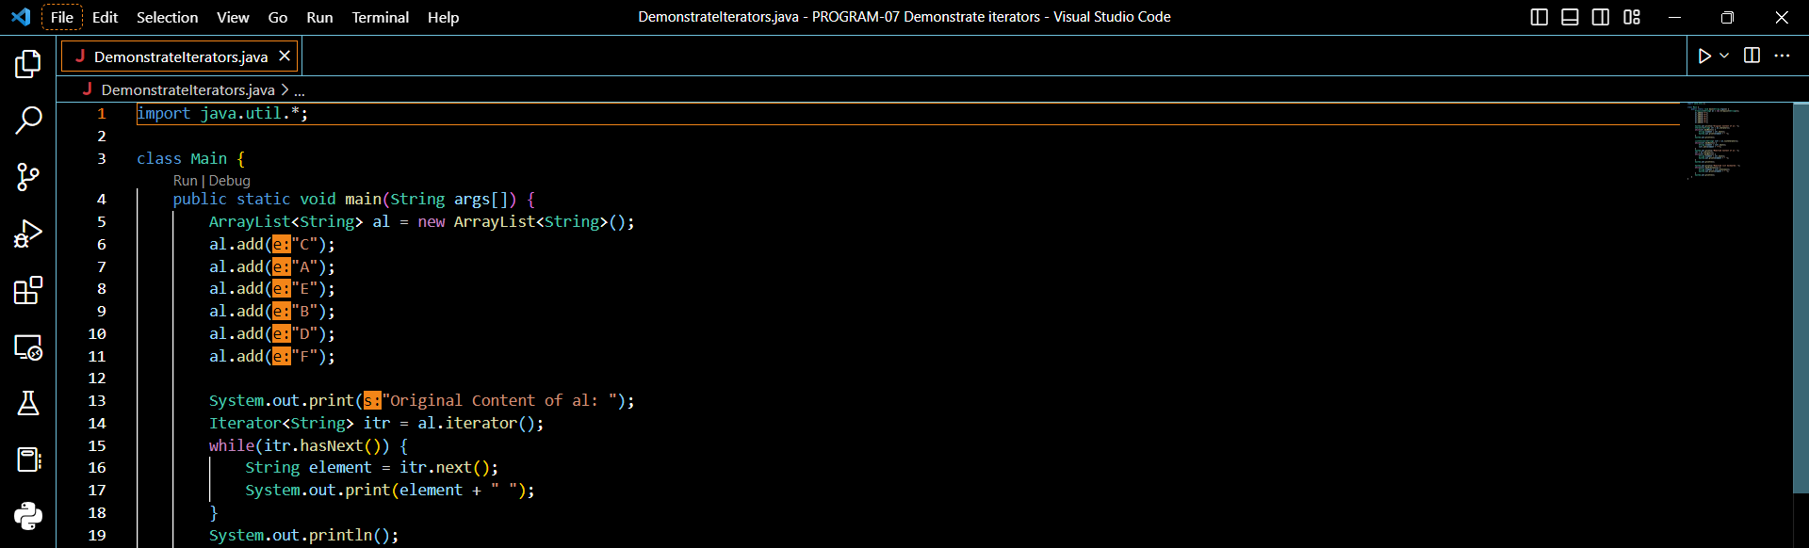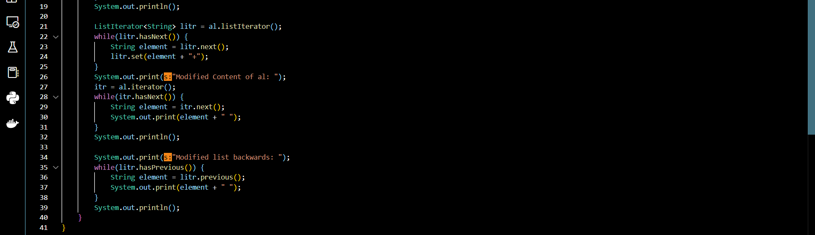

**Result-**

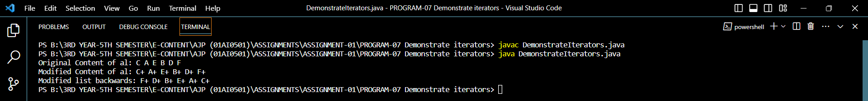

**PROGRAM-08:** Use the for-each for loop to cycle through a Collection.

**CODE:**

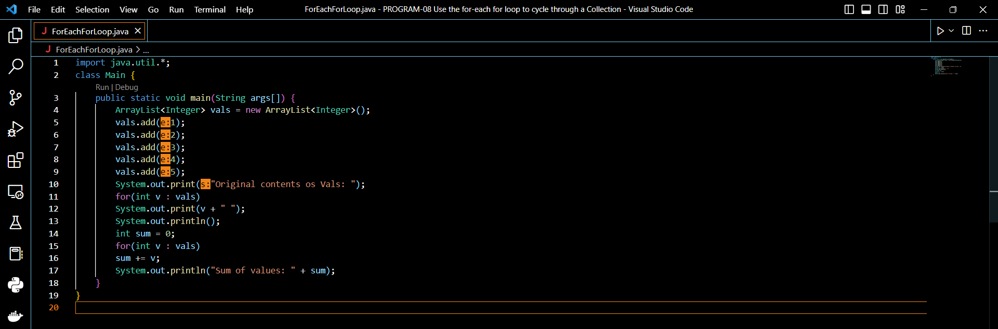

**Result-**

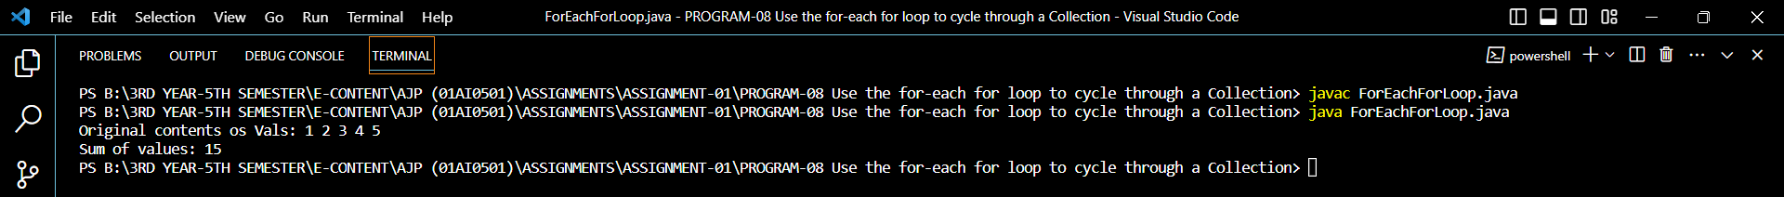

**PROGRAM-09:** Storing User-Defined Classes in Collections

**CODE:**

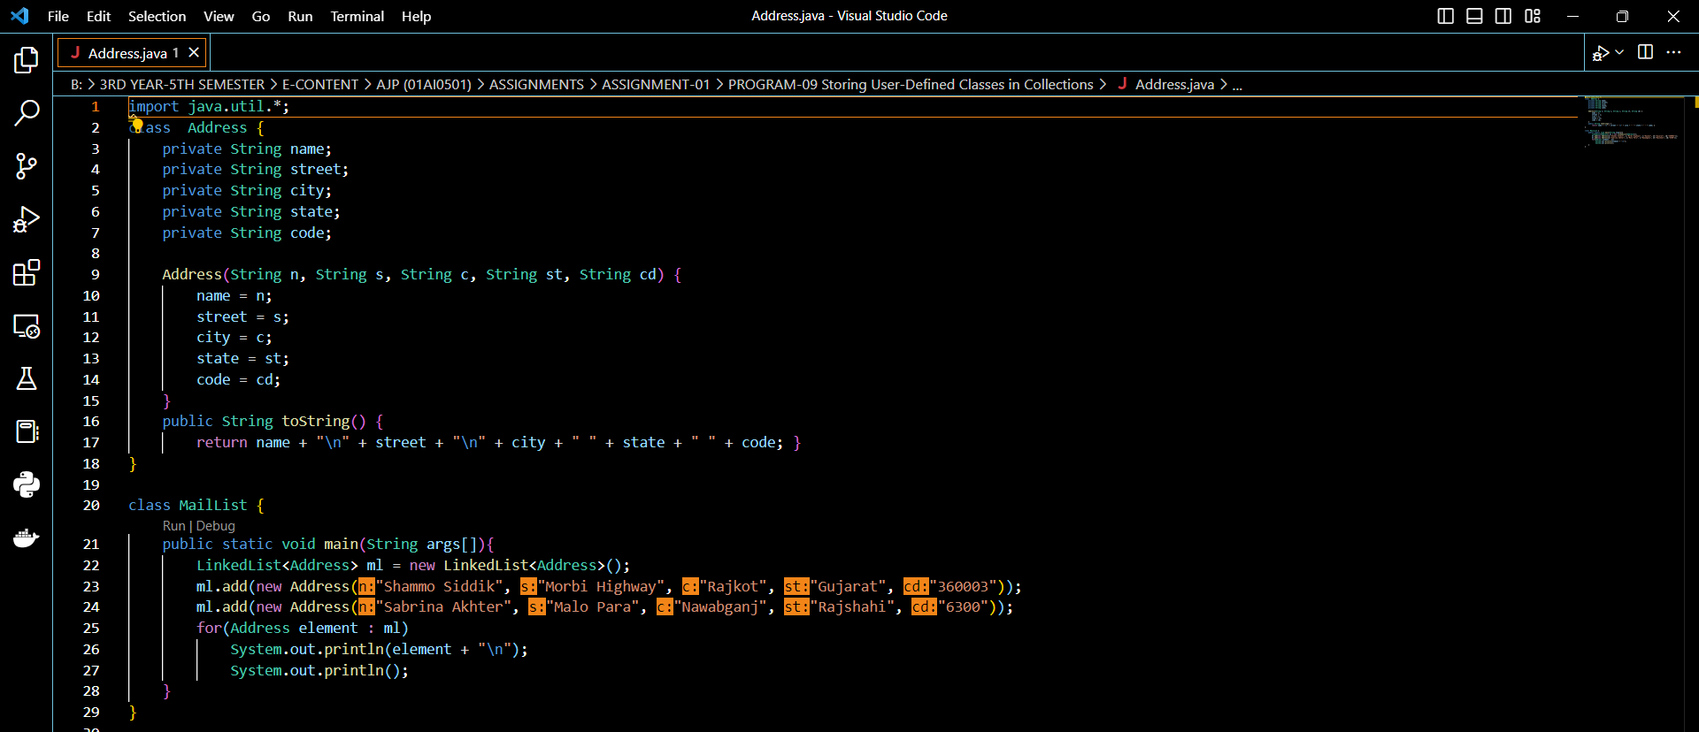

**Result-**

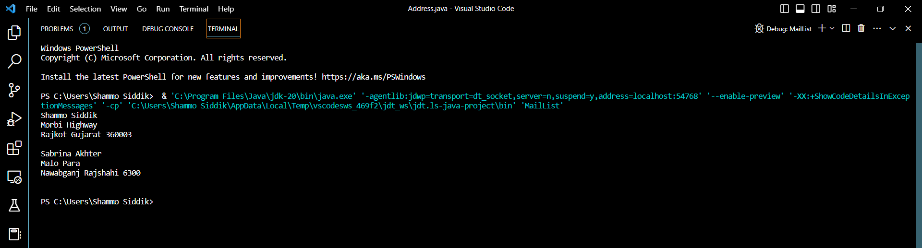

**PROGRAM-10:** The HashMap Class.

**CODE:**

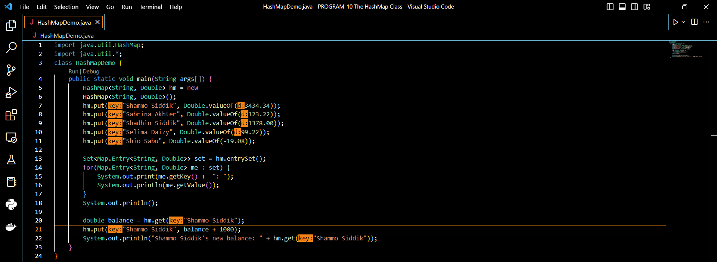

**Result-**

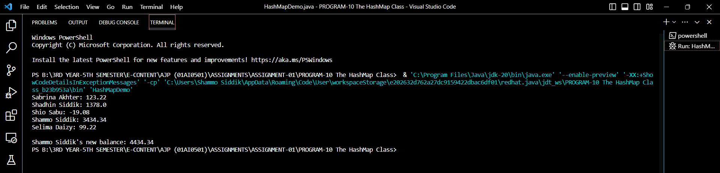

**PROGRAM-11:** The TreeMap Class

**CODE:**

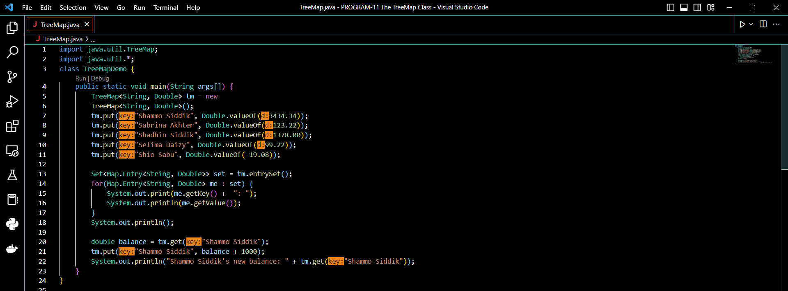

**Result-**

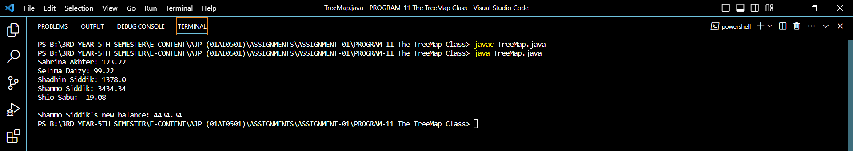

**PROGRAM-12:** Using a Comparator

**CODE:**

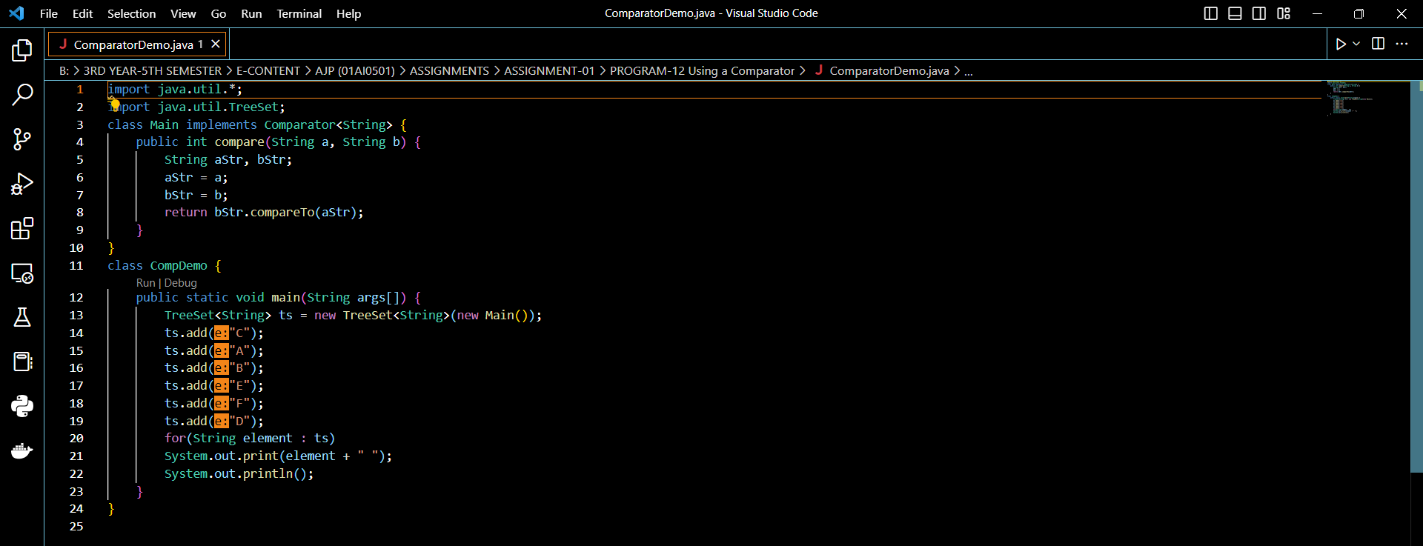

**Result-**

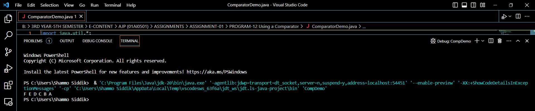

**PROGRAM-13:** Use a comparator to sort accounts by last name.

**CODE:**

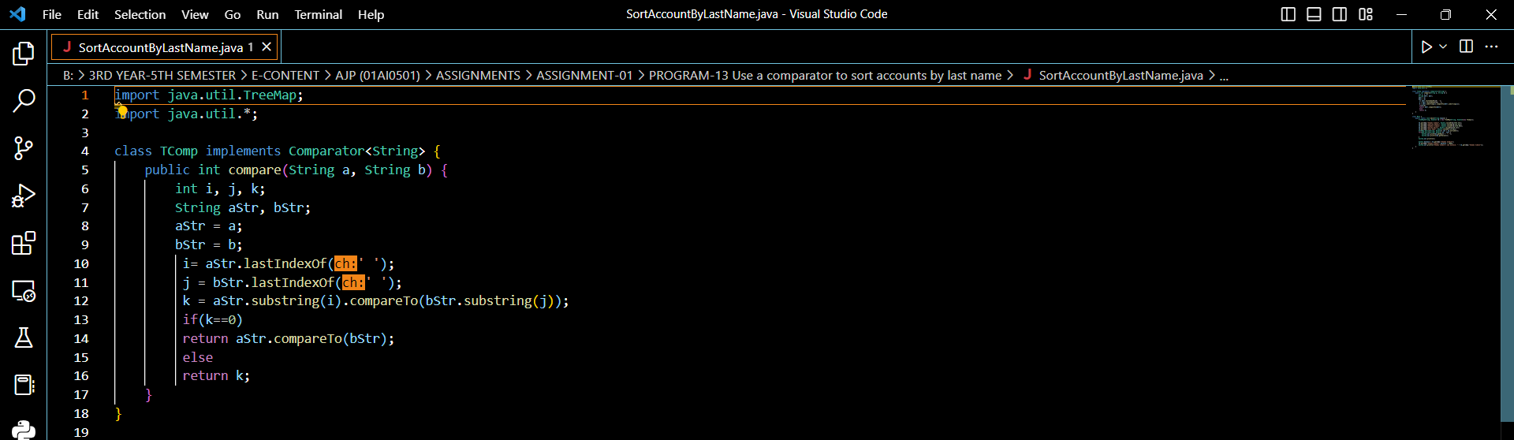

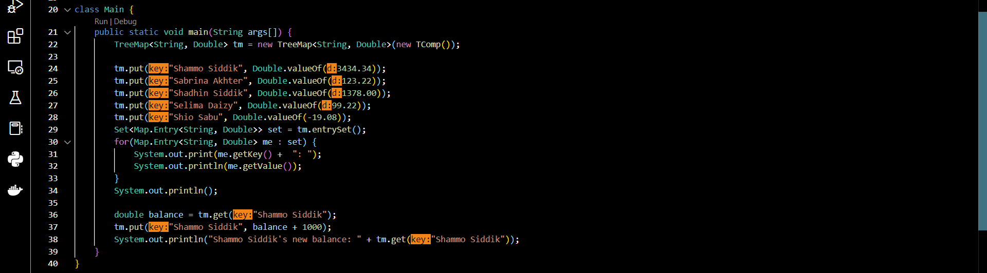

**Result-**

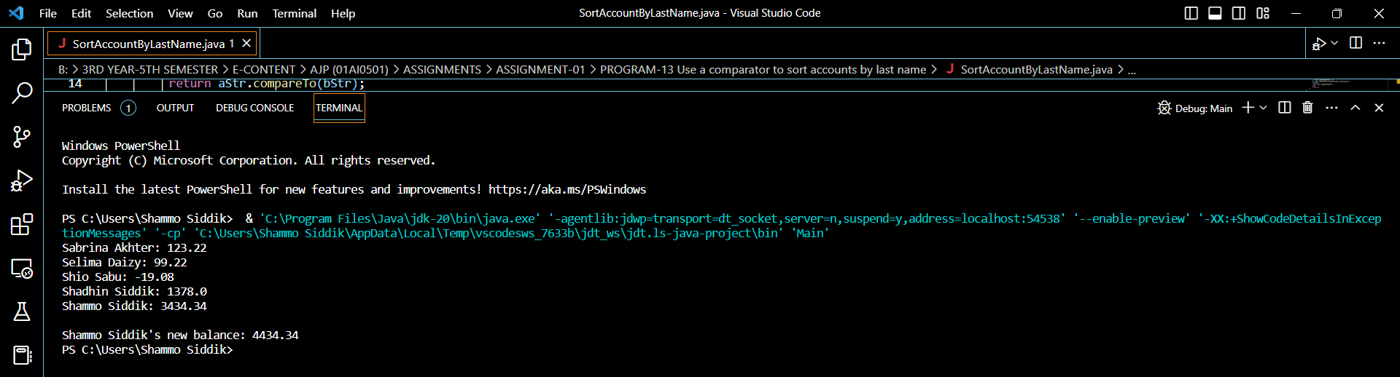

**PROGRAM-14:** Different Algorithms.

**CODE:**

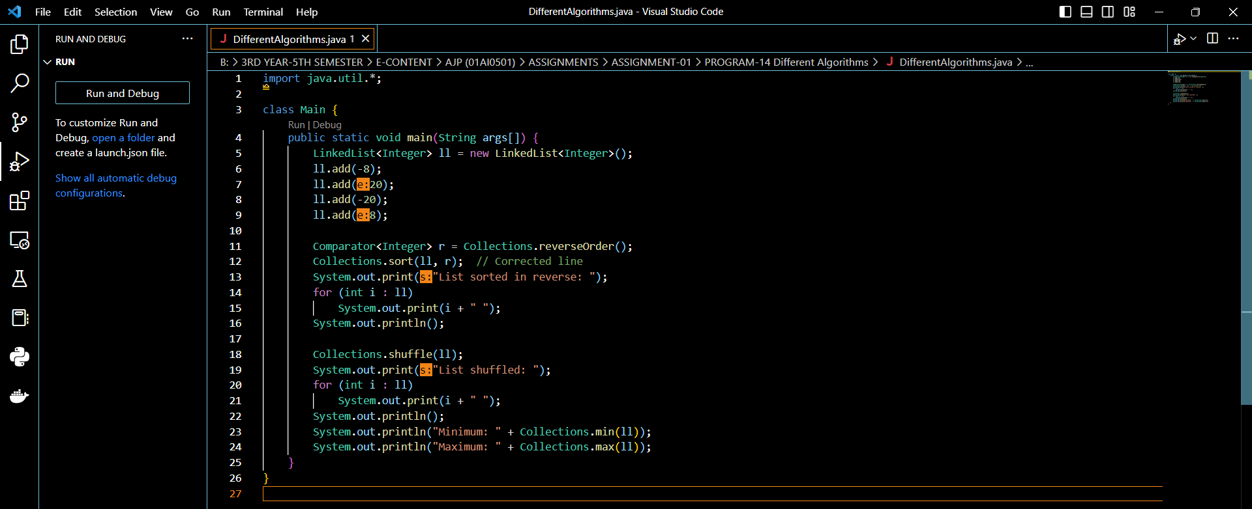

**Result-**

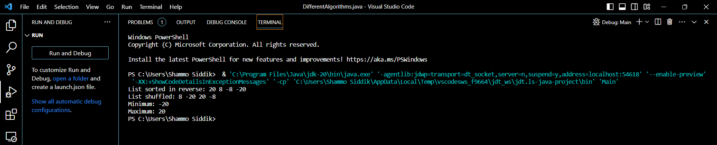

**PROGRAM-15:** Demonstrate Arrays.

**CODE:**

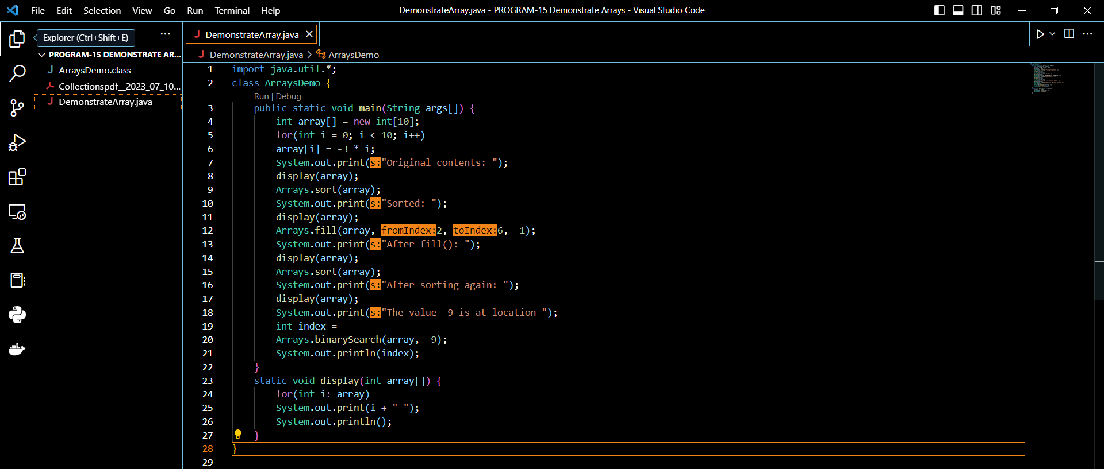

**Result-**

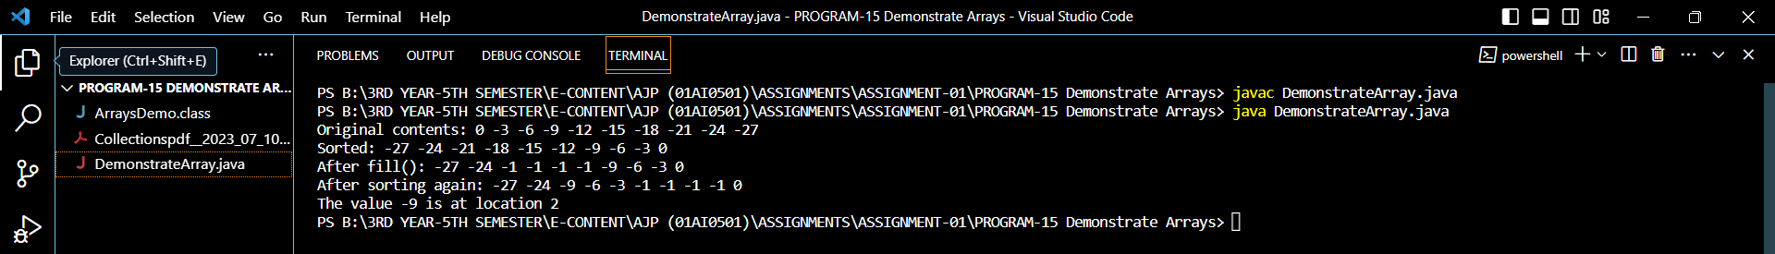

**PROGRAM-16:** Demonstrate various Vector operations.

**CODE:**

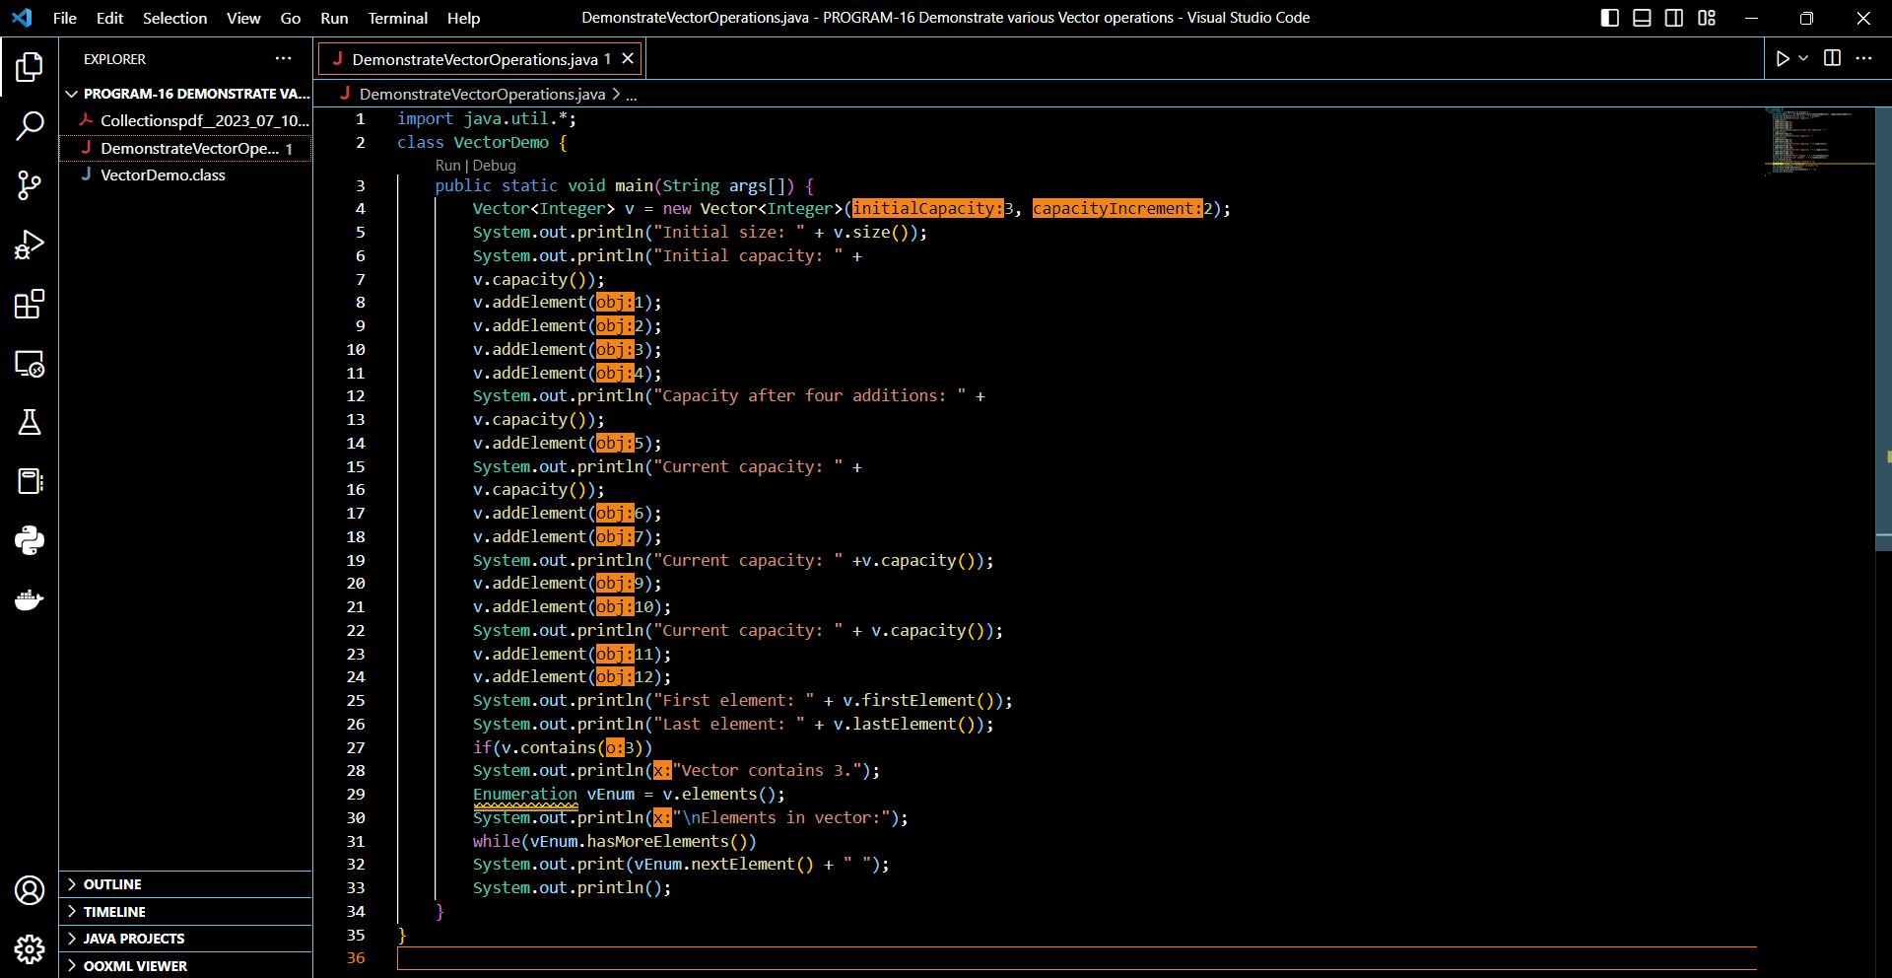

**Result-**

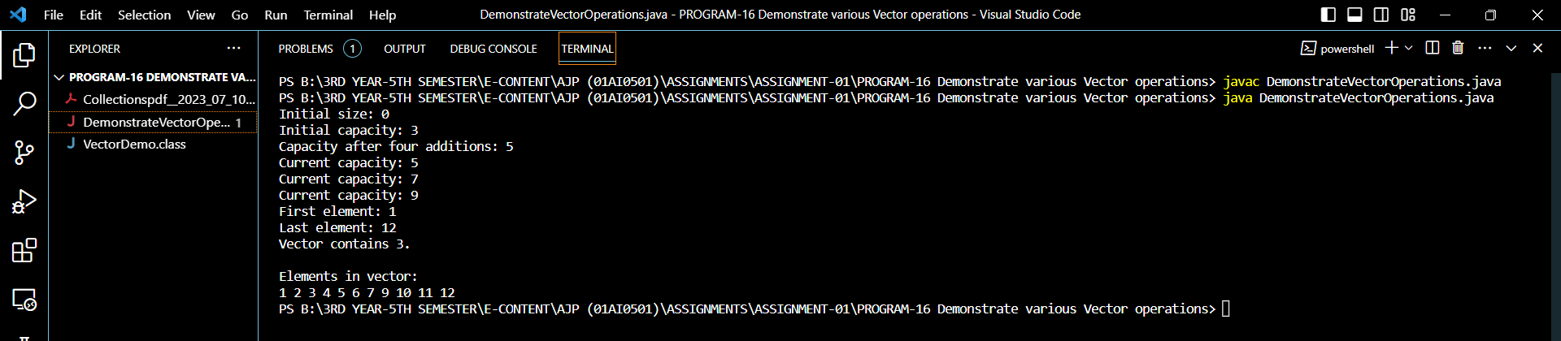

**PROGRAM-17:** Demonstrate the Stack class.

**CODE:**

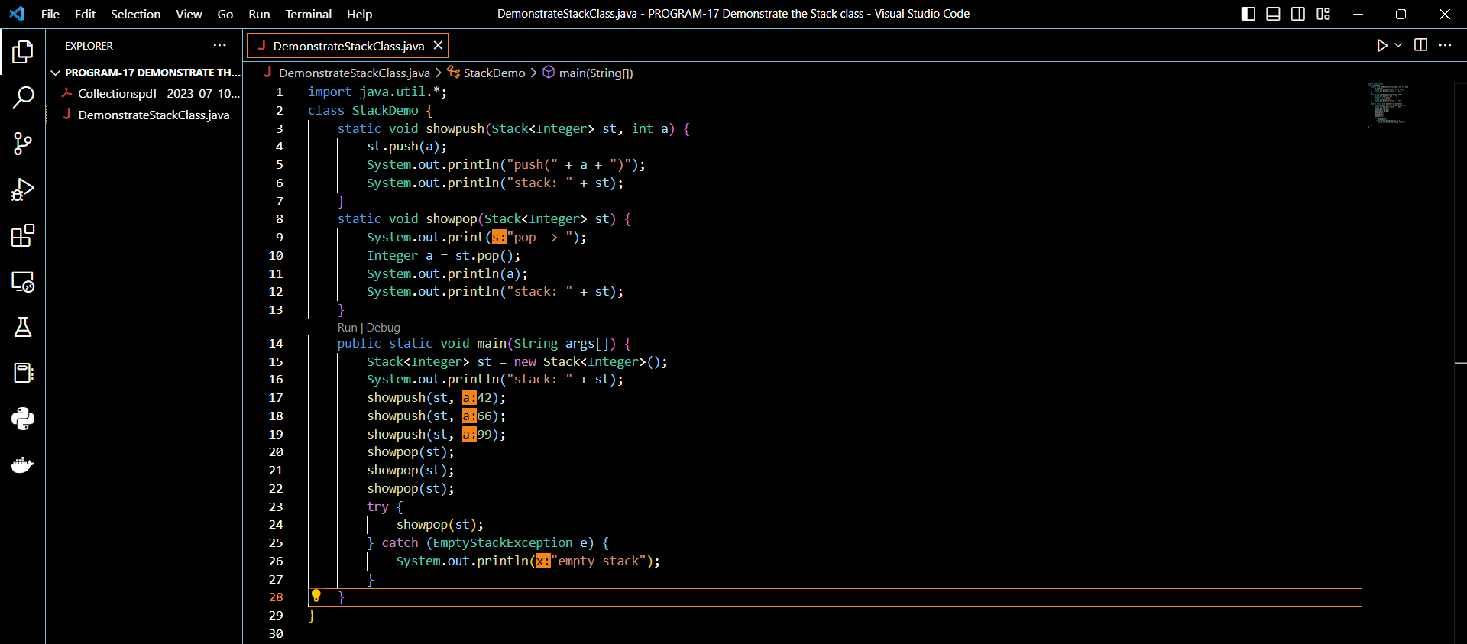

**Result-**

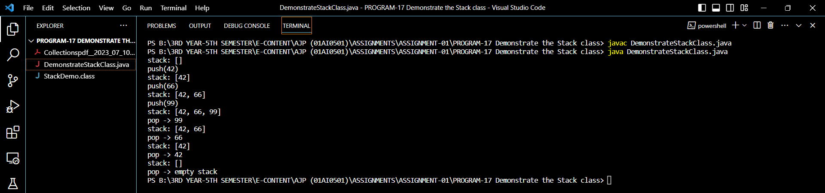

**PROGRAM-18:** Demonstrate Calendar.

**CODE:**

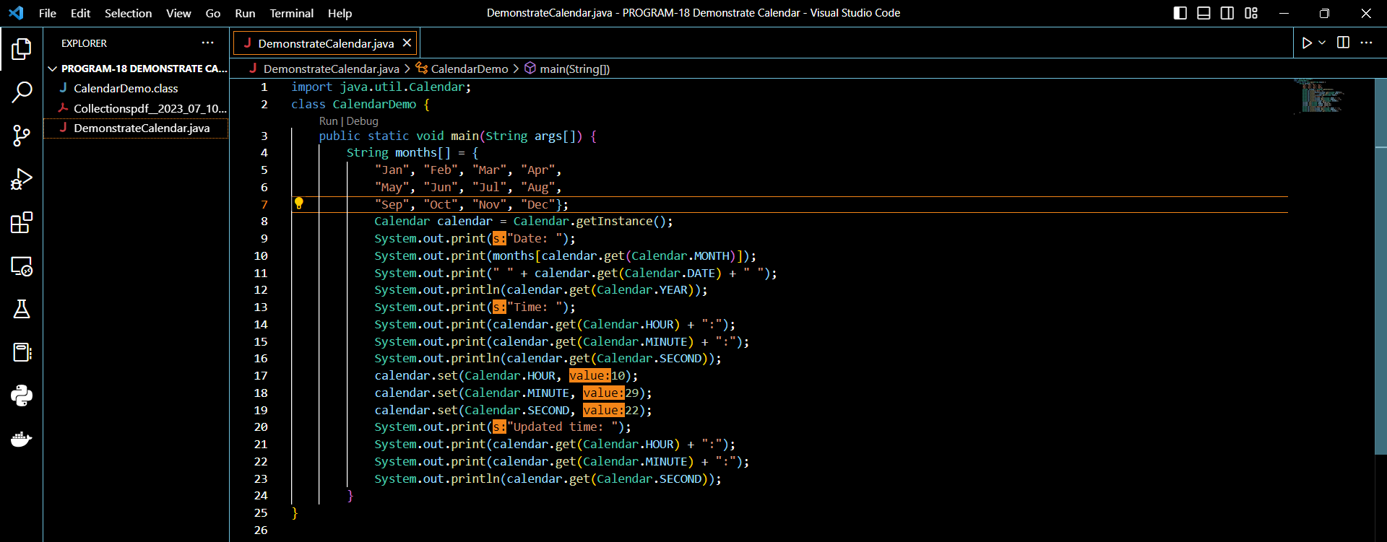

**Result-**

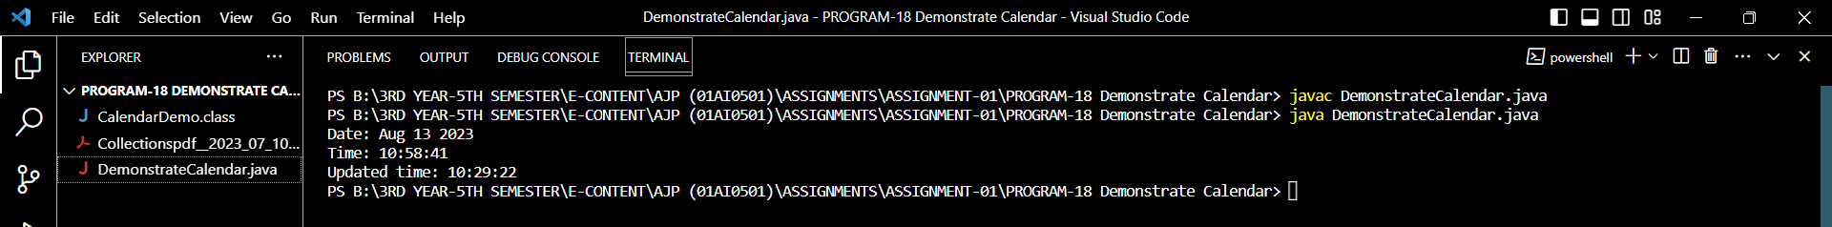

**PROGRAM-19:** GregorianCalendar.

**CODE:**

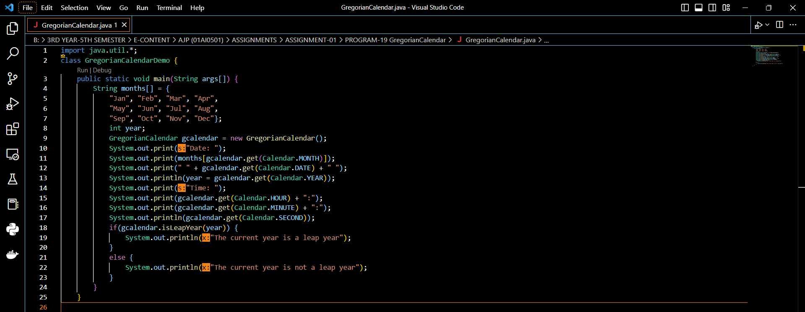

**Result-**

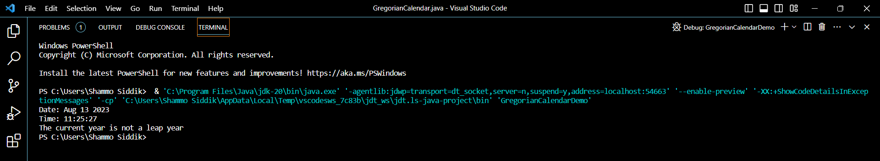

**PROGRAM-20:** Demonstrate Timer and TimerTask.

**CODE:**

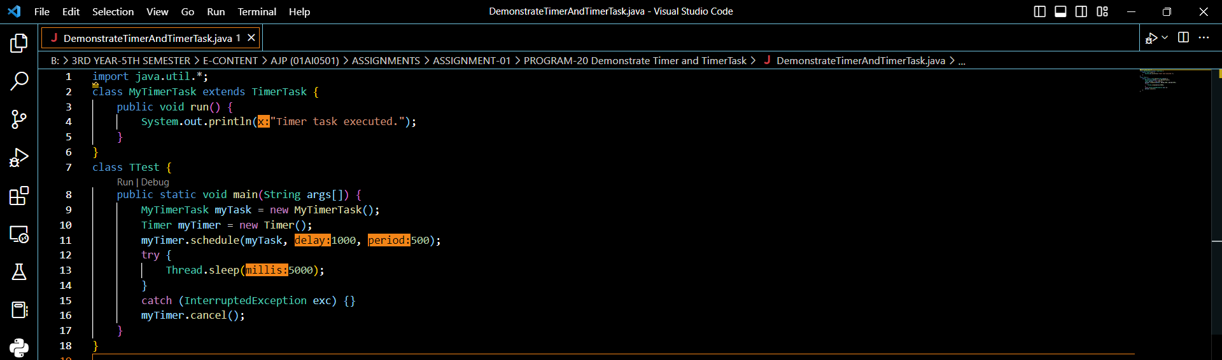

**Result-**

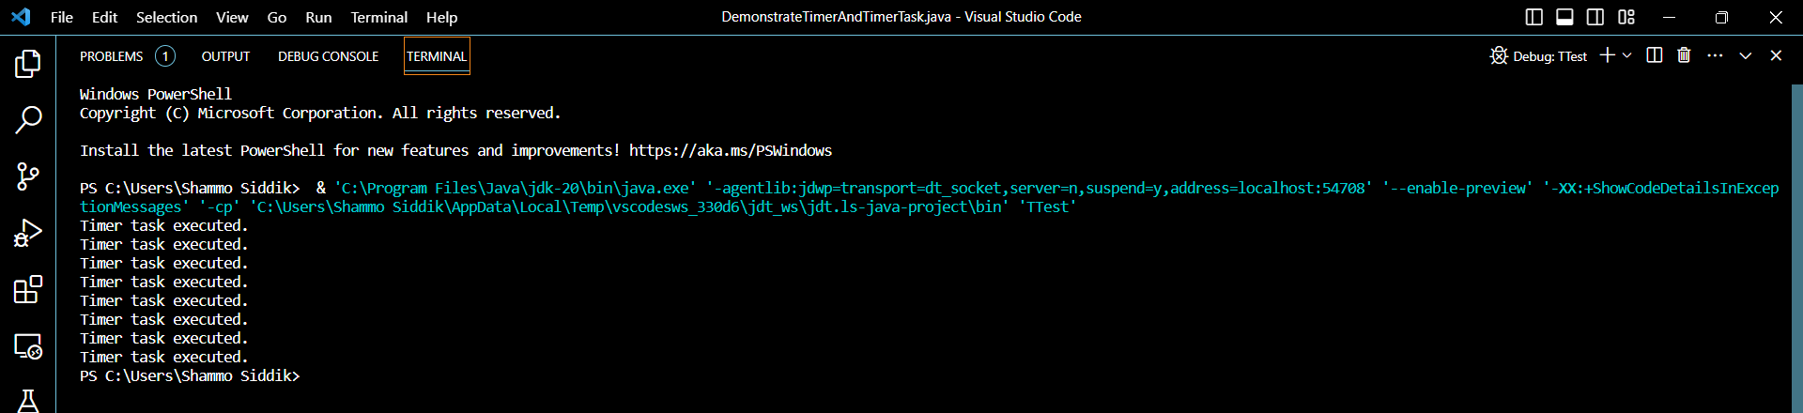

**PROGRAM-21:** Currency.

**CODE:**

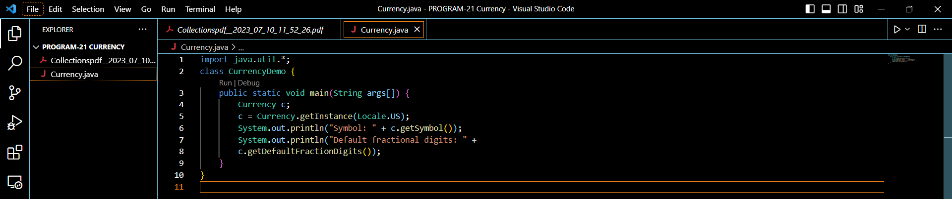

**Result-**

